Capstone Community Aggregate Paper
[Your Name]
NSG 4075 Holistic Professional Nursing
Your Instructor’s Name and credentials go here
South University

Capstone Community Aggregate
The purpose of this paper is to discuss the creation and implementation of a health promotion project by synthesizing all information collected throughout the RN to BSN completion program. [Put the text of your paper here and the last page of your paper is reserved for the references. Please see the South APA Guidelines and South APA Basics documents to ensure that your references are properly constructed].
Introduction & Problem Statement
[Put the text of your paper here providing an introduction to the problem and a clear statement of what you intended to accomplish with your project. INCLUDE the relevancy of the topic you chose, concerns regarding the issue, how this issue impacts nursing and healthcare. INCLUDE literature review references and/or current event articles to support your perspective. Please see the South APA Guidelines and South APA Basics documents to ensure that your references are properly constructed].
Trends and Statistics
[Put the text of your paper here, presenting relevant trends, etiology of the problem, prevalence & incidence statistics (referencing as appropriate) – USE relates statistics form the CDC or other relevant data information and the last page of your paper is reserved for the references. Please see the South APA Guidelines and South APA Basics documents to ensure that your references are properly constructed].
Related Sources
[Put the text of your paper here discussing relevant information to the problem and your project, referencing as appropriate. You must provide at least ONE Peer-Reviewed nursing articles and at least TWO current event articles/internet sites or other forms of media to demonstrate appropriate research. Please see the South APA Guidelines and South APA Basics documents to ensure that your references are properly constructed].
The Client: Objective & Subjective Assessment
[Put the text of your paper here introducing your aggregate and the representative of your aggregate. In the sections below, you will clearly and concisely describe your client using BOTH subjective and objective information. Please see the South APA Guidelines and South APA Basics documents to ensure that your references are properly constructed].
Case Study
[Put the text of your paper here and summarize your findings related to the issues presented by your client and discuss how and intent to improve your client’s health/life. Include both Objective and Subjective information. Please see the South APA Guidelines and South APA Basics documents to ensure that your references are properly constructed].
Aggregates’ Demographics
[Put the text of your paper here present the demographics of the aggregate here (remember an aggregate is a GROUP of people, not just one individual) and the last page of your paper is reserved for the references. Please see the South APA Guidelines and South APA Basics documents to ensure that your references are properly constructed].
Gordon’s 11 Functional Health Patterns
See Appendix B of this paper. You may include your entire Gordon’s information as an appendix, but here you want to SUMARIZE the information and only present items that are relative to the issue you are addressing. Describe the content of the relevant portions of the Gordon’s here. Please see the South APA Guidelines and South APA Basics documents to ensure that your references are properly constructed].
Health Perception and Health Management.[Put the text of your paper here discussing the health perception(s) of the individual that represents your aggregate and his/her current management strategy. Please see the South APA Guidelines and South APA Basics documents to ensure that your references are properly constructed].
Nutrition and Metabolism.[Put the text of your paper here discussing the nutrition and metabolism of the individual that represents you aggregate, if relevant. If NOT relevant, leave this sub-topic out. Please see the South APA Guidelines and South APA Basics documents to ensure that your references are properly constructed].
Elimination. Put the text of your paper here discussing the elimination of the individual that represents you aggregate if relevant. If NOT relevant, leave this subtopic out. Please see the South APA Guidelines and South APA Basics documents to ensure that your references are properly constructed].
Activity and Exercise. [Put the text of your paper here discussing the activity and exercise of the individual that represents you aggregate if relevant. If NOT relevant, leave this subtopic out. Please see the South APA Guidelines and South APA Basics documents to ensure that your references are properly constructed].
Cognition and Perception. [Put the text of your paper here discussing the cognition and perception of the individual that represents you aggregate if relevant. If NOT relevant, leave this subtopic out. Please see the South APA Guidelines and South APA Basics documents to ensure that your references are properly constructed].
Sleep and Rest. [Put the text of your paper here discussing the sleep and rest of the individual that represents you aggregate if relevant. If NOT relevant, leave this subtopic out. Please see the South APA Guidelines and South APA Basics documents to ensure that your references are properly constructed].
Self-Perception and Self-Concept. [Put the text of your paper here discussing the Self-perception and self-concept of the individual that represents you aggregate if relevant. If NOT relevant, leave this subtopic out. Please see the South APA Guidelines and South APA Basics documents to ensure that your references are properly constructed].
Roles and Relationships. [Put the text of your paper here discussing the roles and relationships of the individual that represents you aggregate if relevant. If NOT relevant, leave this subtopic out. Please see the South APA Guidelines and South APA Basics documents to ensure that your references are properly constructed].
Sexuality and Reproduction. [Put the text of your paper here discussing the sexuality and reproduction of the individual that represents you aggregate if relevant. If NOT relevant, leave this subtopic out. Please see the South APA Guidelines and South APA Basics documents to ensure that your references are properly constructed].
Coping and Stress Tolerance. [Put the text of your paper here discussing the coping and Stress Tolerance of the individual that represents you aggregate if relevant. If NOT relevant, leave this subtopic out. Please see the South APA Guidelines and South APA Basics documents to ensure that your references are properly constructed].
Values and Belief. [Put the text of your paper here discussing the values and beliefs of the individual that represents you aggregate if relevant. If NOT relevant, leave this subtopic out. Please see the South APA Guidelines and South APA Basics documents to ensure that your references are properly constructed].
Windshield Survey
[Put the text of your paper here and describing the relevant finding of your Windshield survey in paragraph form. You may include your entire windshield survey as an APPENDIX, but in this section, you should present your findings in paragraph format.
Concept Map
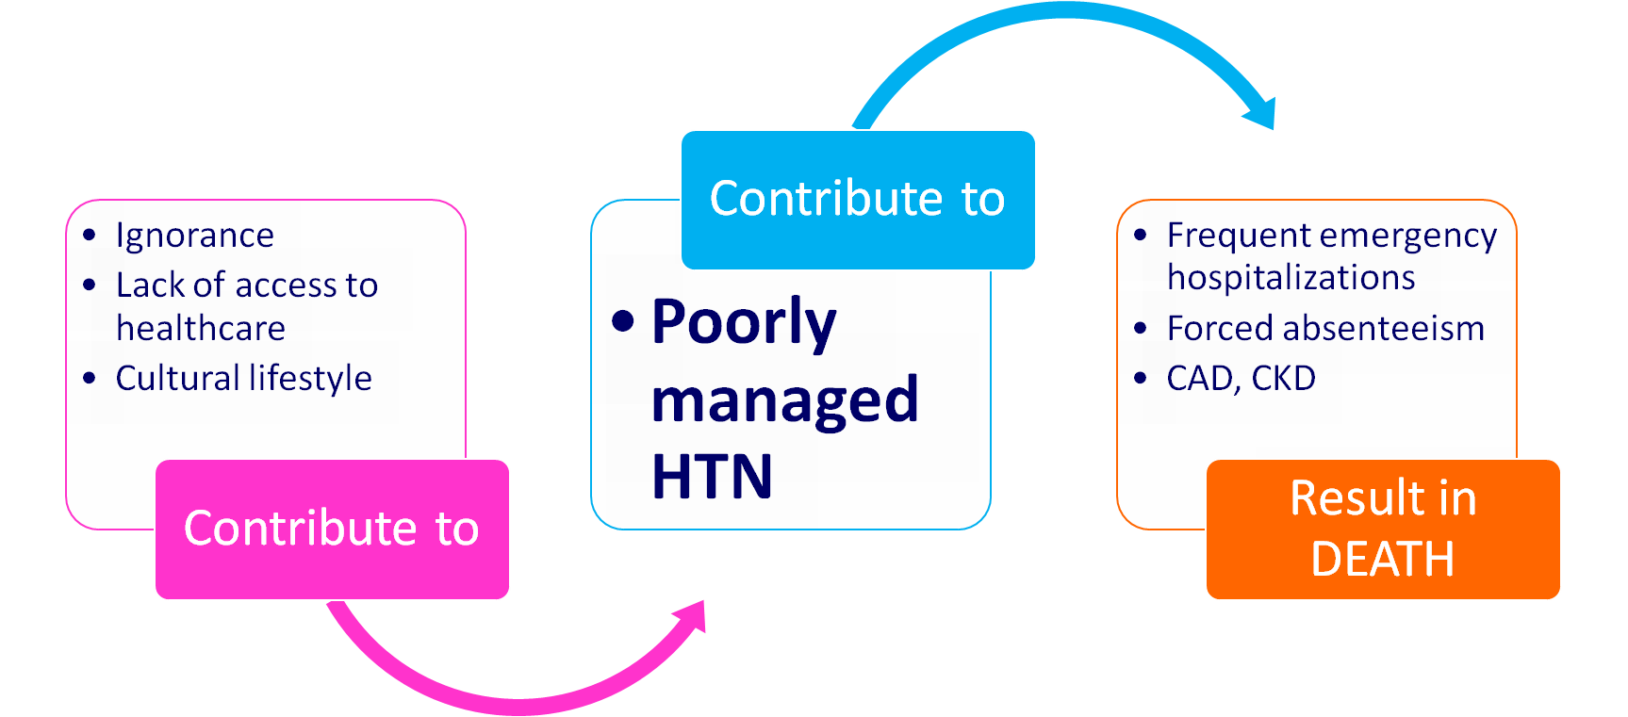
[Put the text of your paper here describing your concept map. THIS is an EXAMPLE of a CONCEPT map – yours may be different. Please see the South APA Guidelines and South APA Basics documents to ensure that your references are properly constructed].
Genogram: One Individual in Aggregate
[Put the text of your paper here and describing the genogram of the individual representing your aggregate, if appropriate. CLEARLY identify your individual in your genograms. Include children of your aggregate exemplar, if appropriate. Please see the South APA Guidelines and South APA Basics documents to ensure that your references are properly constructed].
Paternal Side:
Maternal Side:

Plan of the Project
Community Stakeholder’s Identified
[Put the text of your paper here describing the community stakeholders you have identified related to both your aggregate and the individual with whom you are working who represents your aggregate. Please see the South APA Guidelines and South APA Basics documents to ensure that your references are properly constructed].
[Put the text of your paper here and the last page of your paper is reserved for the references. Please see the South APA Guidelines and South APA Basics documents to ensure that your references are properly constructed].
Financial and Political Implications
[Put the text of your paper here discussing the financial and political implications of your health promotion plan as it relates to both the entire aggregate and the individual that represents your aggregate. Please see the South APA Guidelines and South APA Basics documents to ensure that your references are properly constructed].
[Put the text of your paper here and the last page of your paper is reserved for the references. Please see the South APA Guidelines and South APA Basics documents to ensure that your references are properly constructed].
Feasibility of the Project
Provision of Alternate Plan and Interventions
[Put the text of your paper here discussing an alternative plan if your initial plan does not work. Please see the South APA Guidelines and South APA Basics documents to ensure that your references are properly constructed].
Role of Change Agent
[Put the text of your paper here discuss the role of a change agent and your specific role as the change agent for your aggregate and for the individual that is representing your aggregate. Please see the South APA Guidelines and South APA Basics documents to ensure that your references are properly constructed].
Implementation and Evaluation of the Project
Implementation of the Project
[Describe in detail what you did and how you did it (your health promotion plan) and the progress made. Please see the South APA Guidelines and South APA Basics documents to ensure that your references are properly constructed].
Evaluation of the Project
Evaluation: Did the project intervention address the original identified problem? [Put the text of your paper here describing and critiquing your health promotion plan – i.e. – DID IT WORK? WHY or why not???? and Please see the South APA Guidelines and South APA Basics documents to ensure that your references are properly constructed].
[Put the text of your paper here and the last page of your paper is reserved for the references. Please see the South APA Guidelines and South APA Basics documents to ensure that your references are properly constructed].
Implications to Nursing Practice in the Local Community
[Put the text of your paper here discussing how your plan can affect (or be used by) nurses practicing in the local community. Provide at least three nursing implications that would affect nursing practice in the local community. Please see the South APA Guidelines and South APA Basics documents to ensure that your references are properly constructed].
Implications to Nursing Practice and Global Health
[Put the text of your paper here discussing how your plan might impact nurses around the world and global health. Provide at least three nursing implications that would affect nursing practice in terms of global health. Please see the South APA Guidelines and South APA Basics documents to ensure that your references are properly constructed].
Summary, Recommendations and Conclusion
[Put the text of your paper here presenting your recommendations related to your project as well as a summary of the project and your conclusions Please see the South APA Guidelines and South APA Basics documents to ensure that your references are properly constructed].
[Summarize your paper here, about two to three paragraphs].
References
PLEASE NOTE: These are SAMPLE References. You need to remove these and insert your own references here
Harwood, L., Ridley, J., Wilson, B., & Laschinger, H. (2010). Workplace empowerment and
burnout in Canadian nephrology nurses. CANNT Journal, 20(2), 12-17. Retrieved from CINAHL with Full Text database.
McCaffrey, R., Hayes, R., Stuart, W., Cassell, A., Farrell, C., Miller-Reyes, C., et al. (2010). A
program to improve communication and collaboration between nurses and medical residents. Journal of Continuing Education in Nursing, 41(4), 172-178. doi:10.3928/00220124-20100326-04.
Uyehara, J., Magnussen, L., Itano, J., & Zhang, S. (2007). Facilitating program and NCLEX-RN
success in a generic BSN program. Nursing Forum, 42(1), 31-38. Retrieved from CINAHL with Full Text database.
https://ecampus.phoenix.edu/secure/aapd/cwe/citation_generator/gen.asp

Appendices
Appendix A
Housing | What is the age and condition of housing in the neighborhoods you’re surveying? Are houses and apartment buildings kept up, or are they run-down and in need of repair? Are yards neat or overgrown?  Other buildings. Are the buildings mostly or fully occupied? Do public and commercial buildings seem accessible to people with disabilities – ramped, street level entries, etc.?
Public Spaces | Are there public spaces where people can gather? Are they well kept up? Do they have seating areas, trees and plants, attractive design, cafes or food vendors, or other features meant to encourage people to use the space? Who uses these spaces? Is there diversity?
Parks | Are parks used by a variety of people?? Are they well kept up? Are there sports facilities – basketball courts, soccer pitches, baseball fields, cricket pitches, etc.? Are they used at night?
Culture and Entertainment | Are there museums, libraries, theaters, restaurants, clubs, sports stadiums, historic sites, etc.? Are they accessible to all parts of the community (centrally located, reachable by public transportation)? Do they reflect the cultures of community members?  •Streetscape. The streetscape is the environment created by streets and the sidewalks, buildings, trees, etc. that line them. Are there trees and/or plants? Are there sidewalks? Are building facades and storefronts attractive and welcoming? Are the streets and sidewalks relatively clean? Are there trash cans? Is there outdoor seating?
Street Use | Are there people on the streets at most times of day? In the evening? How late? Do they interact with one another? Are streets and sidewalks well lit at night?
Commercial Activity | What kinds of businesses are there? Are there boarded-up or vacant storefronts? Is there a mix of large and small businesses? Are there grocery stores and supermarkets, pharmacies, and other stores that provide necessities in all parts of the community?
Signs | What languages are business signs in? Are traffic signs informative? Are there signs directing people to various parts of the community (downtown, museums, highways, etc.)?
Industry | What kinds of industry exist in the community? Does it seem to be causing pollution?
Land Use | How much open space is there? How are residential, commercial, and industrial areas distributed? Do major roads or railroad tracks divide neighborhoods, or are they on the edges of the community?
Infrastructure | What is the condition of roads, bridges, sidewalks, etc.? Are there differences in these conditions from one area of the community to another? Do all parts of the community seem to be equally served by electricity, water, phone, fiber optic, wastewater treatment, waste disposal, and other infrastructure services?
Public Transportation | Is there a functioning public transportation system? Is it well used? By whom? Does it allow relatively easy access to all parts of the community? How easy is it to navigate and use? How much does it cost? Are its vehicles energy-efficient?
Traffic | How heavy is traffic in the community? Is it mostly commercial and industrial – vans, trucks, etc. – or mostly private cars? Is there ever gridlock? Is there much bicycle traffic? Are there bike lanes? Are there bike racks in many places?
Environmental Quality | How much usable green space is there, and is it scattered throughout the community? Is there smog or haze? Does the air smell of smoke, garbage, car exhaust, chemicals, industrial waste, etc.? Does the water in streams, ponds, lakes, etc. seem reasonably clear?
Race/Ethnicity. | Who lives in the community? Are there identifiable racial and ethnic groups? Do particular groups seem to live in particular areas?
Faith Communities | What kinds of religious institutions are there? Do the institutions of one particular religion or sect dominate? Are there separate houses of worship for people of different ethnicities or races, even if they share the same faith?
Health Services | How many hospitals and clinics are there in the community? Where are they located? How big are they? How easy are they to get to?
Community And Public Services | Are there identifiable community service providers and organizations in the community – mental health centers, food banks, homeless shelters, welfare offices, etc.? Are they concentrated in a particular area? Are they easy to reach by public transportation?
Community Safety | Where are police and fire stations located? Are they in good repair? Is the community well-lit at night?
Public Schools | Are schools in different neighborhoods in noticeably different states of repair? Are schools well maintained? Or in some developing countries, are there schools in the community at all?
Higher Education | Are there two- and four-year colleges and/or universities in the community? Where are they located? Do they seem open to the community, or do they seem self-contained and isolated?
Political Activity | Are there signs or other indications of political activity? Is it clear that political activity is allowed and/or encouraged? Are there protests or demonstrations?
Community Organizations | What evidence is there of organizations in the community? Are there service clubs – Lions, Elks, Masons, etc.? Are there other organizations – centered around community issues, the environment, sports or leisure pursuits, socialization, etc.?
Media | Are there local media outlets – radio and TV stations, newspapers, Internet sites devoted to local issues? Are they independent, or are they sponsored or run by government or corporations? Where are their facilities?
Differences Among Neighborhoods Or Areas Of The Community | What are the differences among different parts of the community? Are schools, stores, public and other buildings, streets, etc. in different areas in different condition? Do some areas seem neglected, while others are clearly maintained?
Over-All Impression of the Community | The “feel” of the community. What is your overall impression of the community?

Appendix B
Gordon's Functional Health Patterns
Marjorie Gordon (1987) proposed functional health patterns as a guide for establishing a comprehensive nursing data base. These 11 categories make possible a systematic and standardized approach to data collection, and enable the nurse to determine the following aspects of health and human function:
Health Perception and Health Management. Data collection is focused on the person's perceived level of health and well-being, and on practices for maintaining health. Habits that may be detrimental to health are also evaluated, including smoking and alcohol or drug use. Actual or potential problems related to safety and health management may be identified as well as needs for modifications in the home or needs for continued care in the home.
Nutrition and Metabolism Assessment is focused on the pattern of food and fluid consumption relative to metabolic need. The adequacy of local nutrient supplies is evaluated. Actual or potential problems related to fluid balance, tissue integrity, and host defenses may be identified as well as problems with the gastrointestinal system.
Elimination. Data collection is focused on excretory patterns (bowel, bladder, skin). Excretory problems such as incontinence, constipation, diarrhea, and urinary retention may be identified.
Activity and Exercise. Assessment is focused on the activities of daily living requiring energy expenditure, including self-care activities, exercise, and leisure activities. The status of major body systems involved with activity and exercise is evaluated, including the respiratory, cardiovascular, and musculoskeletal systems.
Cognition and Perception. Assessment is focused on the ability to comprehend and use information and on the sensory functions. Data pertaining to neurologic functions are collected to aid this process. Sensory experiences such as pain and altered sensory input may be identified and further evaluated.
Sleep and Rest. Assessment is focused on the person's sleep, rest, and relaxation practices. Dysfunctional sleep patterns, fatigue, and responses to sleep deprivation may be identified.
Self-Perception and Self-Concept. Assessment is focused on the person's attitudes toward self, including identity, body image, and sense of self-worth. The person's level of self-esteem and response to threats to his or her self-concept may be identified.
Roles and Relationships. Assessment is focused on the person's roles in the world and relationships with others. Satisfaction with roles, role strain, or dysfunctional relationships may be further evaluated.
Sexuality and Reproduction. Assessment is focused on the person's satisfaction or dissatisfaction with sexuality patterns and reproductive functions. Concerns with sexuality may he identified.
Coping and Stress Tolerance. Assessment is focused on the person's perception of stress and on his or her coping strategies Support systems are evaluated, and symptoms of stress are noted. The effectiveness of a person's coping strategies in terms of stress tolerance may be further evaluated.
Values and Belief. Assessment is focused on the person's values and beliefs (including spiritual beliefs), or on the goals that guide his or her choices or decisions.
Reference:
Koshar, J. (n.d.). Retrieved on September 29, 2014 from http://www.sonoma.edu/users/k/koshar/n340/N345_Gordon_FHP.html

Appendix C
NSG 4075 Scholarly Capstone Paper Rubric
Week Due | TOPIC to be ADDRESSED and COVERED | Potential  Points | EARNED  Points
Week 2  10/12/15 | Introduction & Problem Statement
DATE DUE | • Rationale of relevancy regarding chosen issue/topic | 3
4/17/16 | • Concerns clearly stated regarding chosen issue/topic | 3
 | • Description of how this particular topic impacts Nursing and Healthcare | 3
 | • Includes literature review references and/or current events articles to support your perspective | 3
Week 3 | Trends & Statistics
DATE DUE | • Identify trends | 3
4/24/16 | • Etiology | 3
 | • Prevalence & incidence | 3
 | • Related statistics from CDC (www.cdc.gov) website (or other relevant –related data base | 3
 | Related Sources
DATE DUE | • Provide at least one peer‐reviewed nursing article | 2
4/24/16 | • Provide at least two current events articles/internet/use of media | 2
Week 4 | The Client: Objective & Subjective Assessment
DATE DUE | • Case Study | 3
5/1/16 | • Aggregates’ demographics | 3
 | • Assessment Data: Case Study | 3
Week 5 | Additional Assessment Data
DATE DUE | • Windshield Survey | 6
5/816 | • Concept Map | 6
Week 6 | Genogram: One Individual in Aggregate
DATE DUE | - Include both sides of family | 5
5/15/16 | - Include children as applicable
Week 7 | Plan of Project
DATE DUE | • Stakeholder’s identified | 3
5/22/16 | • Financial and political implications | 3
 | Feasibility of the project
DATE DUE | • Provision of alternate plan and interventions | 3
5/22/16 | • Role of change agent | 3
Week 8 | Implementation of Project
DATE DUE  5/29/16 | - Written report of how you have (and perhaps are still) implementing your project and you progress so far | 25
Week 9 | Summation
DATE DUE  6/5/16 | • Evaluation  Did the project intervention address the original identified problem? | 2
 | • Implications to Nursing Practice Locally  Provides at least three nursing implications that would affect nursing in the local  community of practice | 2
 | • Implications to Nursing Practice Global Health  Provides at least three nursing implications that would affect nursing practice in  terms of global health | 2
 | • Summary, Recommendations and Conclusion  Synthesize all information and clearly present in APA style | 3
Week 10 | Completed Scholarly Capstone Project (30 % of course grade) | 100 points
DATE DUE | REMEMBER – 10% per day will be deducted from each week’s total points earned
6/12/16 | FINAL GRADE
Appendix D
Writing the your Research Project and Scholarly Paper from Start to Finish

To assist you writing your Problem Statement, please access the link:
https://owl.english.purdue.edu/owl/resource/957/01/

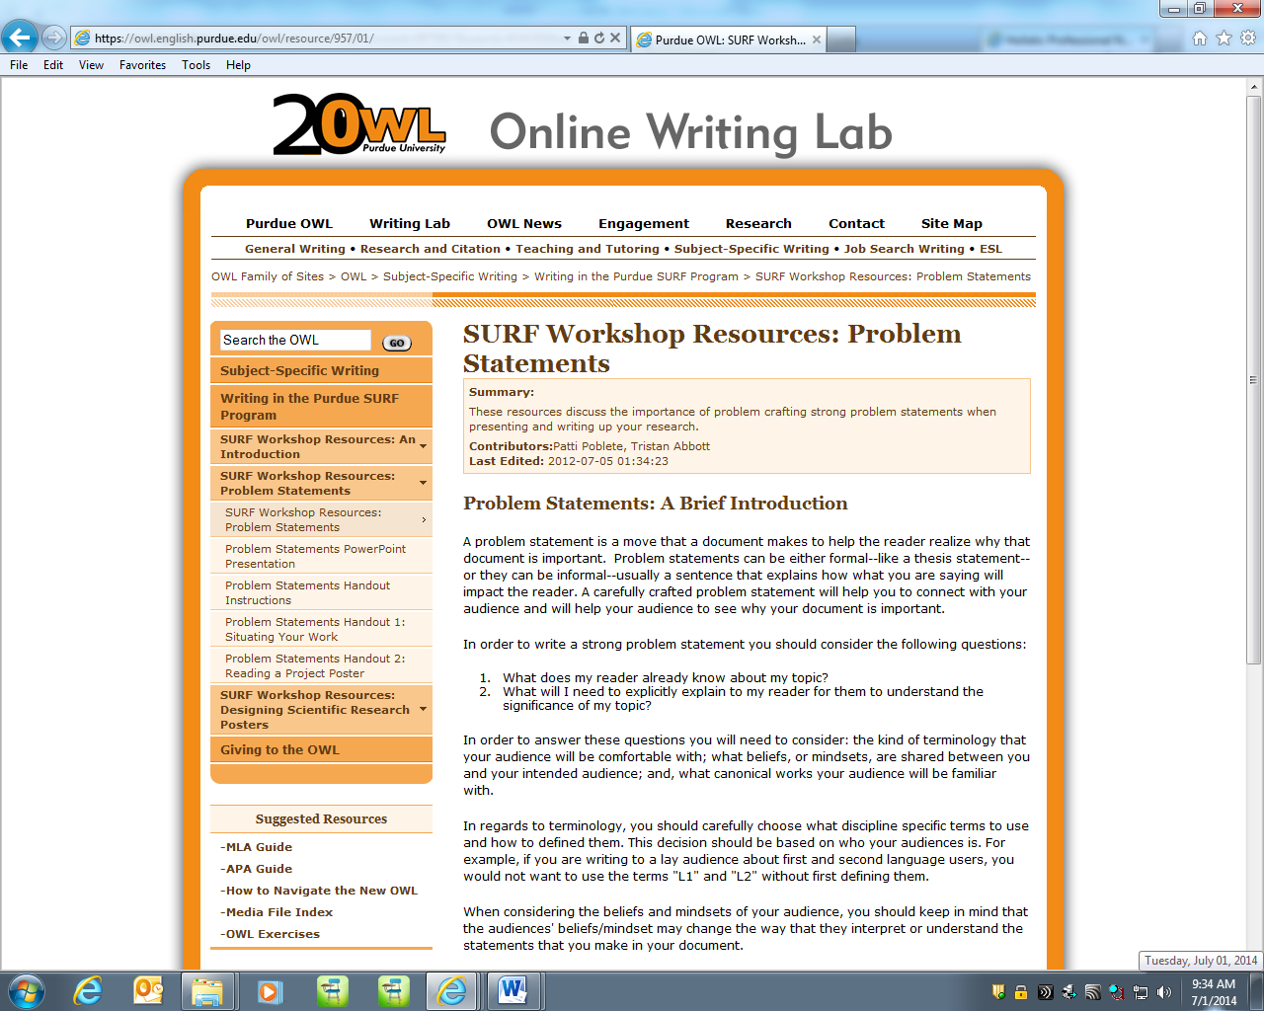
APA Template: http://tinyurl.com/suapa
Course Research Guide
Log in to your portal by clicking “My Campus” at http://inside.southuniversity.edu/
Scroll down and on the right column of your home screen, you will find LIBRARY RESOURCES
Locating Articles: Nursing Research
- CINHAL Plus with Full text
- Nursing and Allied Health (ProQuest)
- OVID Allied Health Collection
- PubMed
- Cochrane Library

